
Carers & Helpers Noticeboard
A central point of contact for support for unpaid carers 0300 303 9988 Phonelines are open Monday to Friday 8am-7pm Saturday 9am-12pm E: provide.essexwellbeing@nhs.net or https://essexwellbeingservice.co.uk/support/carers/
Mid Essex
February 2025



are being held across regions of Essex next month. Each event will be split into 2 sessions with the first 1½hr devoted solely to professionals who work in health or social care, education, the voluntary or community sector, who in their working role may sometimes have contact with unpaid/ family carers.
There will be opportunity to informally network with other professionals across the system and to learn about the range of support services locally available to unpaid carers. As well as finding out about the work done to date on the Essex Carers Programme and the next steps planned by the Council. Use the QR to . book a place on one of the professional sessions or E: essex.carers@essex.gov.uk
are hosting a Carers Health & Wellbeing event on 19th March 10am to 4pm at Cressing Temple Barns, Braintree CM77 8PD. Free guided walks around this historical site will be on offer along with workshops and pre-bookable Reiki, Pilates, mindfulness, and yoga sessions.

Carers will have the opportunity to have an NHS Health Check, receive training in the use of a defibrillator and on how to perform CPR. A marketplace of health and wellbeing services will also be in attendance to showcase the types of support they can offer to unpaid carers. For more information and to book a place at this event E: essexcarers@carersfirst.org.uk
or call 0300 303 1555.

Region | MID Tuesday 18th March | SOUTH Thursday 20th March | WEST Tuesday 25th March | NORTH Thursday 27th March
Venue | Little Baddow Memorial Hall North Hill CM3 4TA | The Wick Community Centre, Wickford SS12 9NR | The Link, Great Pardon Community Ass. CM19 4RT | Acorn Hall, The Oak Tree Centre, Colchester CO4 3DH
Professionals only  (booking required) | 9:00am - 10:30am | 1:00pm - 2:30pm | 1:00pm - 2:30pm | 9:00am - 10:30am
Professionals & general public (no booking required) | 10:30am - 12:30pm | 2:30pm - 4:30pm | 2:30pm - 4:30pm | 10:30am - 12:30pm

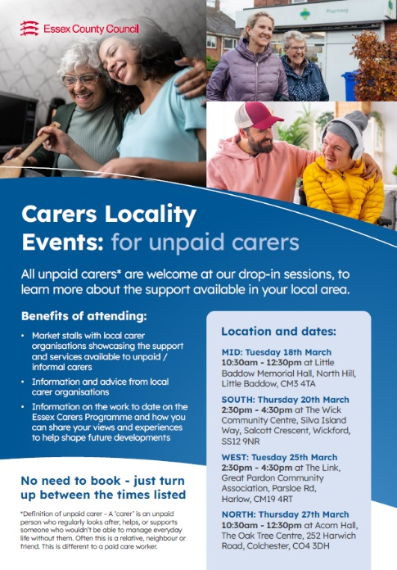
The second part of the day is open to all unpaid carers/ family/ friends who regularly look after or support someone who could not manage without their help. No prior booking is needed to attend as these sessions will take the form of an open, drop in market stall event with lots of local support services in attendance.
Email Rachel.Amoss2@essex.gov.uk if your GP Practice or health clinic would like printed leaflets (as shown on the left) or A4 posters to advertise these events to patients/ service users.


is the new name of the Rural Community Council of Essex’s community led social project, United in Kind. RCCE is part of EWS. The work of Kinder Essex coaches is to reduce social isolation and to support people’s wider health and wellbeing by connecting people to local groups/activities, through volunteering or by of acts of kindness.
Coaches also work with local groups and organisations in helping to start new community projects and with extending existing services. In 2024, the project recruited 500 new volunteers and assisted over 250 groups and organizations. And, in the last five years has helped 20,000 people to become more connected, supported 1,500 new community initiatives and encouraged 46,000 acts of kindness. Click logo for more information about the service.

The Sleep Well project is one of these acts of kindness, inviting local crafters to make eye masks for giving to patients having to stay overnight in a Mid Essex hospital. Volunteers can make an eye mask at home or at one of Kinder Essex’s new sewing group sessions. Contact your local Kinder Essex Coach to find out more about participating in the Sleep Well project:
Braintree District | Jayne Laken | jayne.laken@ceessex.org.uk | tel: 07458 3 00903
Chelmsford District | Kelly Coombs | kelly.coombs@ceessex.org.uk | tel: 07540 720610
Maldon District | Jane Owen | jane.owen@ceessex.org.uk | tel: 07514 726338


The Stroke Association offers a wide range of information on preventing, understanding, and life after a stroke, for professionals, stroke survivors and their Carers. These guides are free to download and are available in a variety of languages, in large print and as audio recordings. For stroke survivors with communication difficulties it also has a range of free tools that can help the person communicate both at home and in healthcare settings. Click logo above for this information or call the Stroke Support Helpline on 0303 3033 100.

In Mid Essex, the Stroke Association offer a personalised stroke recovery service for adult stroke survivors and their family carers (including those who have experienced a TIA/mini stroke). Through phone calls and/or home visits, a SA coordinator can provide practical advice, tailored information and emotional support to both survivors and carers to help with managing daily activities, and with rebuilding confidence and independence after a stroke. For more info E: Julie.pamment@stroke.org.uk or call 07717 275767


is an online resource offering expert information on palliative care and end of life care for people living with a life-limiting illness, their family and loved ones. Life-limiting illnesses such as chronic lung, heart, kidney or neurological diseases, dementia or general frailty, as well as incurable cancer, are often long-term and progressive and so a person’s care needs can change over time. The term ‘end of life care’ refers specifically to the care provided during the last year of a person’s life.

The HPAL website aims to support anyone who needs, or is involved with, palliative and end of life care, whether in a hospice, care home or in their own home. Articles on the website cover a broad range of topics to help with a person’s physical, emotional, social, financial, legal and spiritual needs with many written specifically with informal carers in mind. Topics covered include:
- Managing physical symptoms and pain
- Practical guides for caring for someone at home
- Guidance for people facing bereavement and grief
- How to prepare children that a parent or grandparent is dying
- Guidance on advance care planning and thinking about care needs and wishes for the future.
Click on logo for the sites home page or go to https://mse.medindex.co.uk/p


Family Support Service provides support to adults with a life-limiting illness and their families at the hospice’s impatient unit in Chelmsford, over the phone/video link or via home visits. It offers tailored support including:
- Expert information about different life-limiting illnesses and the impact on individuals and their families
- Counselling and emotional support
- Signposting to financial and welfare advice
- Specialist self-management courses for carers and family members
- Opportunities to access peer support with people facing similar situations
- Advocacy and support with practical issues including housing, funeral planning and advance care planning.
Click logo for more information or call Farleigh’s clinical advice line on 01245 455478 or email familysupport@farleighhospice.org

Young Onset Dementia is categorised as someone first developing symptoms before the age of 65 years. The earliest, noticeable symptom of Young Onset Dementia is often not a deterioration in memory but changes in personality and behaviour, social and communication skills, movement and coordination, or in their vision and spatial awareness. More information and advice on YOD, and other less common types of dementia, can be found by clicking on the Dementia UK and Rare Dementia Support logos on the left.
Or call the Dementia UK Helpline on 0800 888 6678

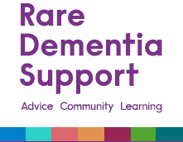

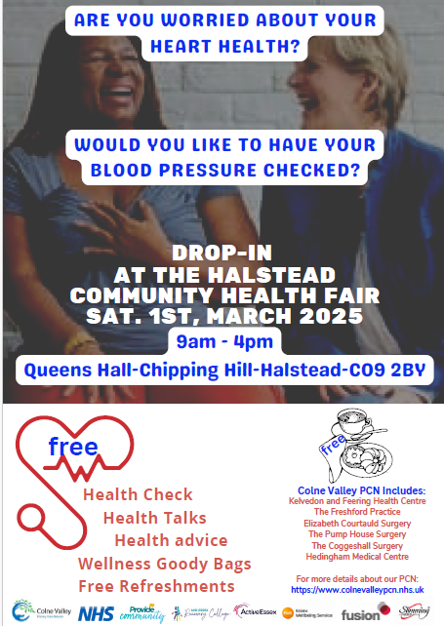
will be hosting a free webinar on Advance care planning and Young Onset Dementia on Tuesday 11th March at 12-1pm. Leading international experts will be offering advice on the importance and challenges of advanced
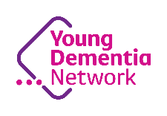

care planning, giving suggestions on how to approach this holistically as well as answering any questions attendees may have.
To book a place click on logo or E: youngdementianetwork@dementiauk.org



Click on image to participate in this survey or telephone Healthwatch on 0300 500 1895 or email carersvoices@healthwatchessex.org.uk.

